Ideation Phase
Empathize & Discover

Date | 31 March 2026
Team ID | SWTID-2026-4754
Project Name | Automating Employee Data
Maximum Marks | 4 Marks

Empathy Map Canvas:
An empathy map is a simple, easy-to-digest visual that captures knowledge about a user’s behaviours and attitudes.

It is a useful tool to helps teams better understand their users.
Creating an effective solution requires understanding the true problem and the person who is experiencing it. The exercise of creating the map helps participants consider things from the user’s perspective along with his or her goals and challenges.
Example :
: 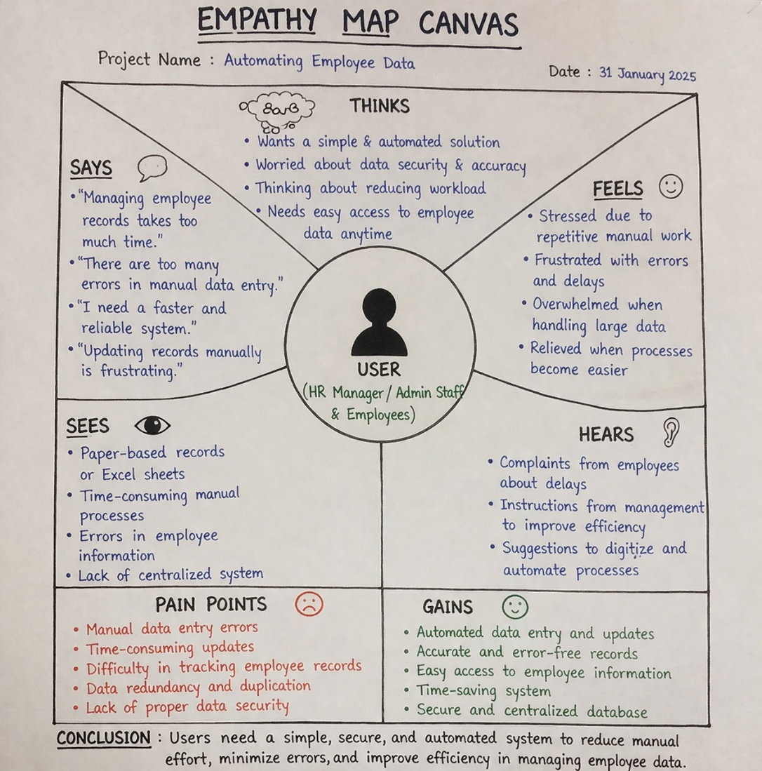

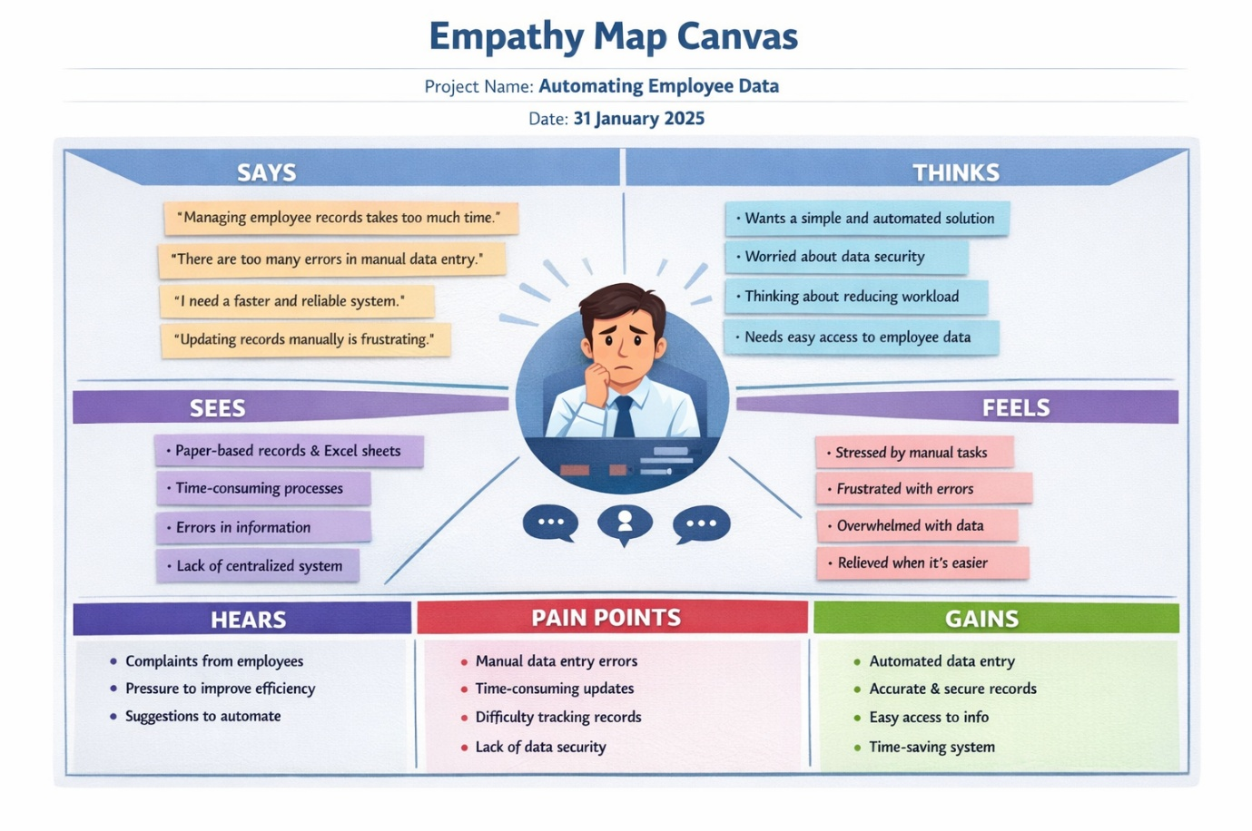

Reference: https://www.mural.co/templates/empathy-map-canvas

User (Who are we empathizing with?)
- HR Manager / Admin Staff
- Employees who submit and update their data

Says (What does the user say?)
- “Managing employee records takes too much time.”
- “There are too many errors in manual data entry.”
- “I need a faster and reliable system.”
- “Updating records manually is frustrating.”

💭 Thinks (What does the user think?)
- Wants a simple and automated solution
- Worried about data security and accuracy
- Thinking about reducing workload
- Needs easy access to employee data anytime

😊 Feels (What does the user feel?)
- Stressed due to repetitive manual work
- Frustrated with errors and delays
- Overwhelmed when handling large data
- Relieved when processes become easier

👀 Sees (What does the user see?)
- Paper-based records or Excel sheets
- Time-consuming manual processes
- Errors in employee information
- Lack of centralized system

👂 Hears (What does the user hear?)
- Complaints from employees about delays
- Instructions from management to improve efficiency
- Suggestions to digitize and automate processes

⚡ Pain Points (Challenges faced)
- Manual data entry errors
- Time-consuming updates
- Difficulty in tracking employee records
- Data redundancy and duplication
- Lack of proper data security

🎯 Gains (User Needs & Goals)
- Automated data entry and updates
- Accurate and error-free records
- Easy access to employee information
- Time-saving system

✅ Conclusion
The empathy map shows that users need a simple, secure, and automated system to reduce manual effort, minimize errors, and improve efficiency in managing employee data .

